MUSA presents…

**Topolo-gami Recreational Math Night**

Thursday, October 20, 2016

1015 Evans, 6pm

**Math Monday Series**

-E+F = 2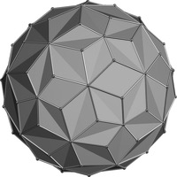

**Peer Advising Night**

This week's Recreational Math Night will not only have interesting, fun math problems to work on, but also center around a theme of **Origami** and **Topology**. The event will begin with a crash course in constructing origami polyhedra, and then we will provide a **hands-on** introduction to the topology and geometry of surfaces. **Snacks** will be provided!

On **Wednesday, October 19 at 5:30pm in 939 Evans**, MUSA will be hosting Peer Advising Night! Come and ask questions to Peer Advisors about next semester’s courses, potential math instructors and suitable workloads. Get an idea what courses to take and how to make a manageable yet successful semester. Snacks will be provided!